1.Commad: whoami
Displays the current user account.
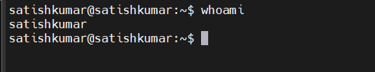
2.Command : ls
Lists file and directory in current directory
3.command : ip a
List IP address and network interface
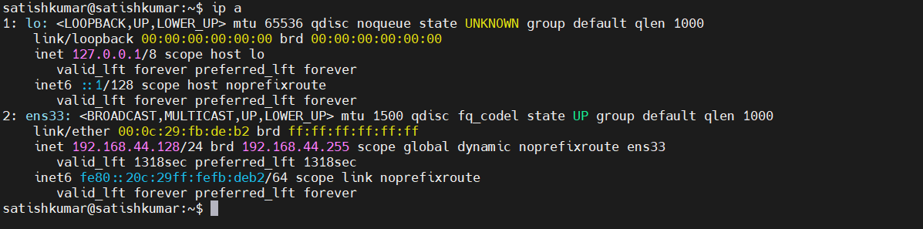
4.Command : cat
Read the content of file.
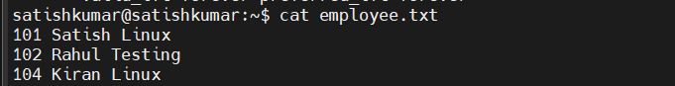
5.Command: passwd
Change password of the user account
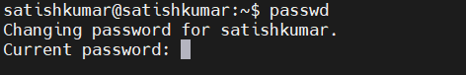
6.command: touch
Create empty file
7.Command : pwd
Present working directory, it shows in which directory you are in.
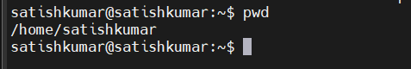
8.Command : man
Access system docu for commands
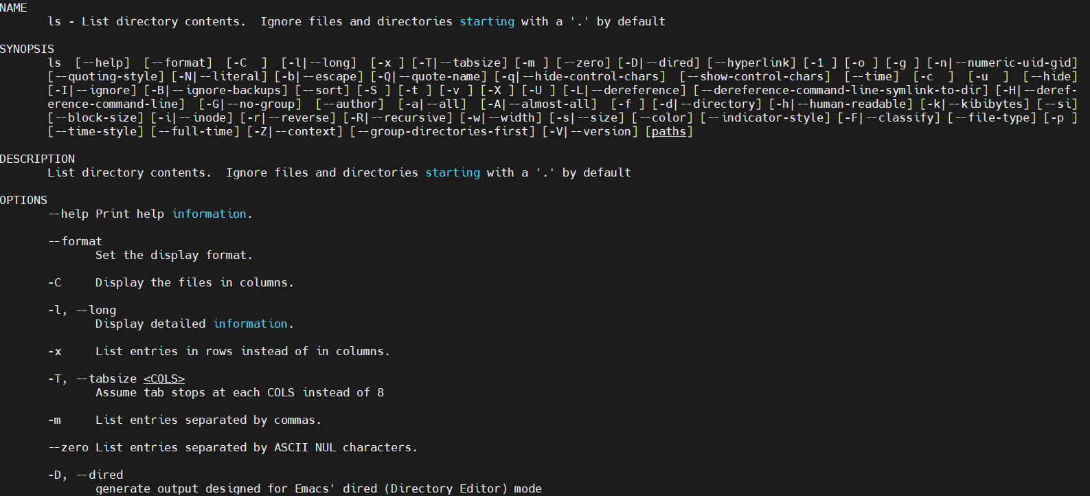
9.Command : apropos
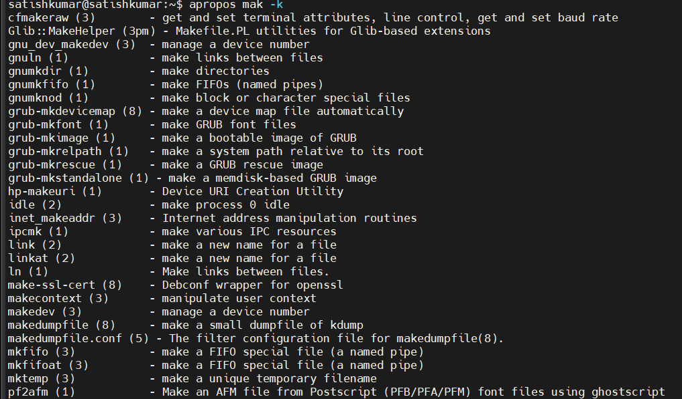

10. Command : pinfo
It provides information like man but we need to install fist using command sudo apt install pinfo
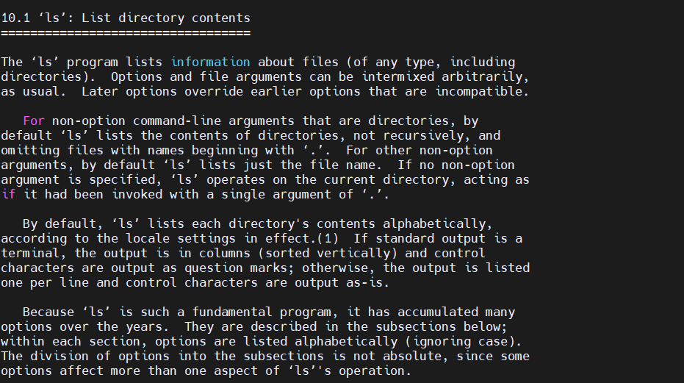
11.Command : tldr
Shows command line

Essential File Management Tools Commands

Command: ls
Command: cp
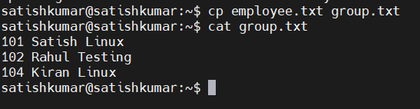
Command : mkdir
Create new directory

Command: mrdir
Remove directory but if its empty
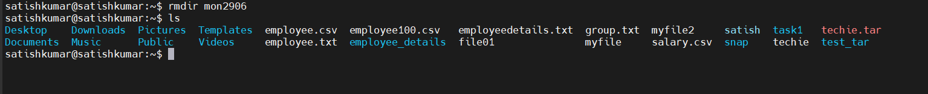

Command: mv
Moves or renames files and directories.

Command : rm
Remove file or directory
Command : rm -rf
that can delete directories and their contents without asking for confirmation

Advanced File Management Tools Commands
Command: ln
Create softlink (shorcut)
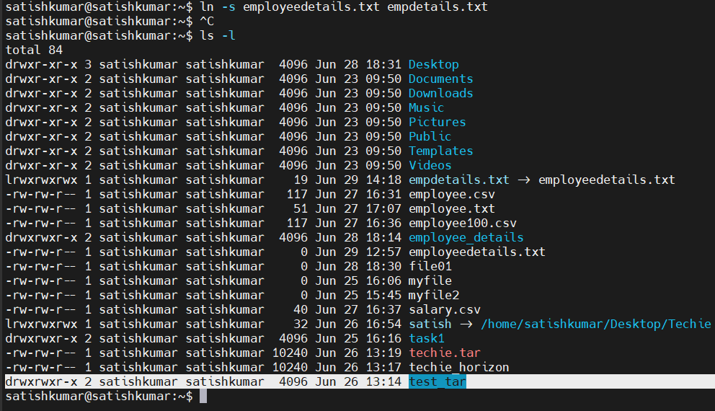
Command: find /path – name filename
Find by name
Command : sudo find / -name “techie_horizon”
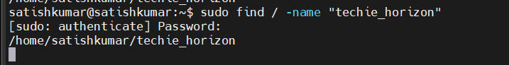

Command : find /path -size +1M
Find by size
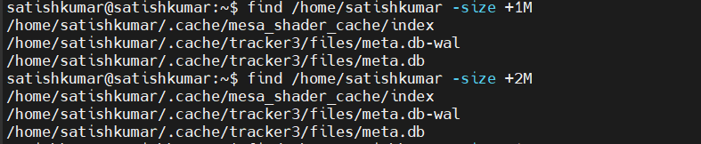
Command : find /home/satishkumar -mtime +1
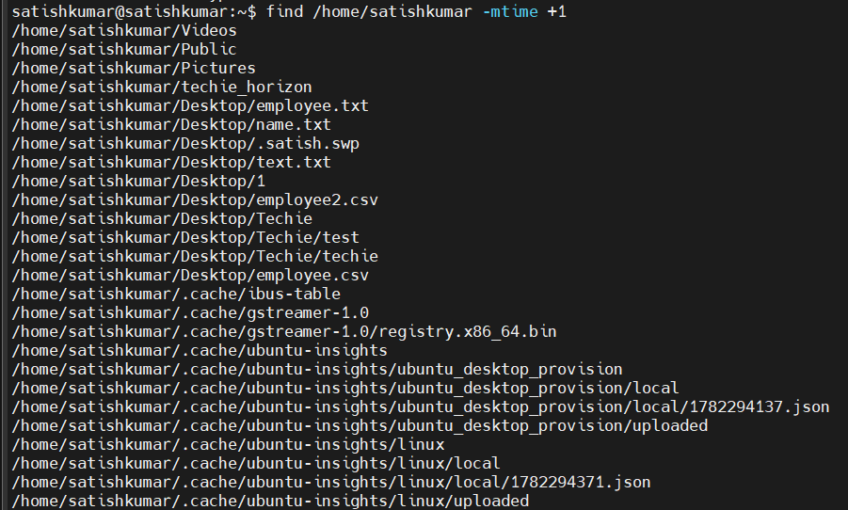

Command : find /home/satishkumar -mtime +7
Find all files older than 7 days
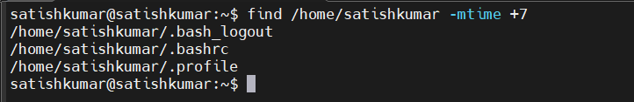

Command : find /home/satishkumar -mtime -1
Find all files modified in 24 hours
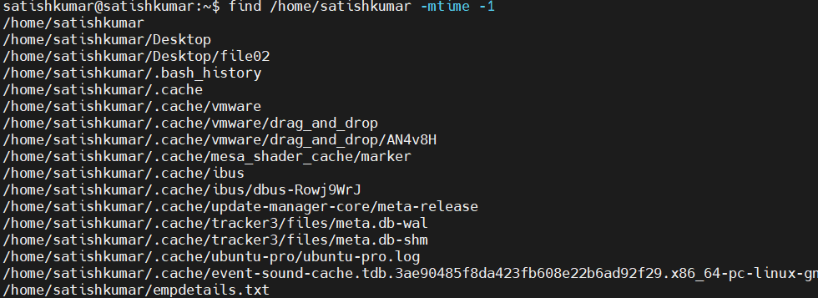
Command : find /home/satishkumar mtime -7
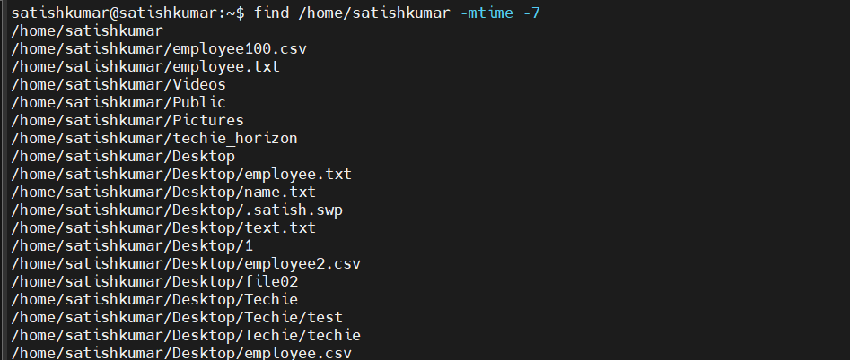
Command : find /home/satishkumar -name[aA]
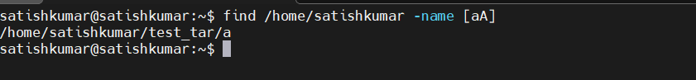

locate: Used for quickly searching the database of system's contents.
Command : locate techie
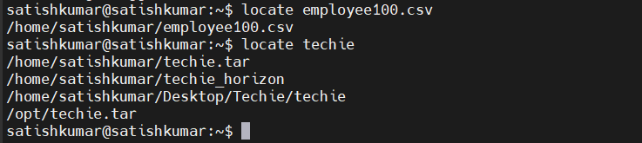

which: Finds the location of executables in the PATH.
Command : which python
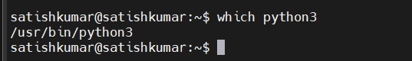

tar
1.command : tar -cvf backup.tar salary.csv salary.csv
2.command : tar -xvf backup.tar
3.command : tar -xvf backup.tar -c /home/satishkumar
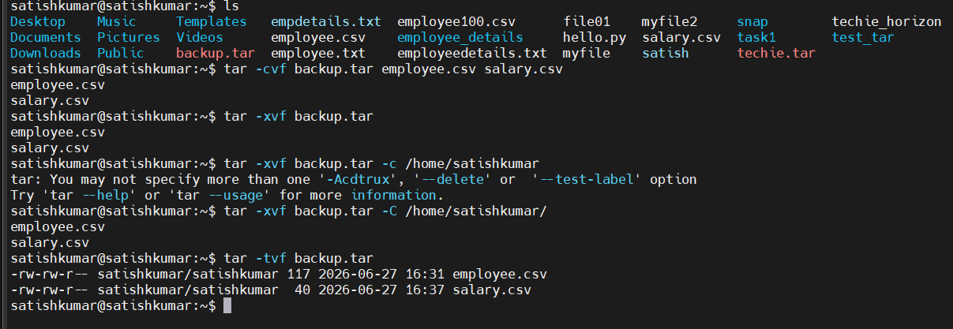

gzip: Compresses files.
Command : gzip
File showing in red colour are zip files
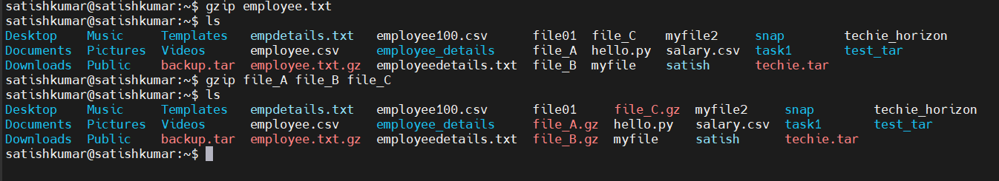

gunzip: Compresses files.

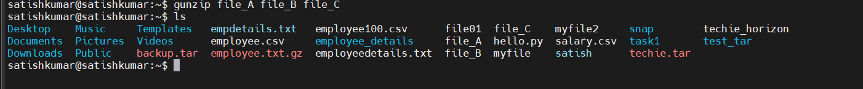

bzip2 Command in Linux
The bzip2 command is used to compress files. It generally provides better compression than gzip, but it is slower.
Output : error
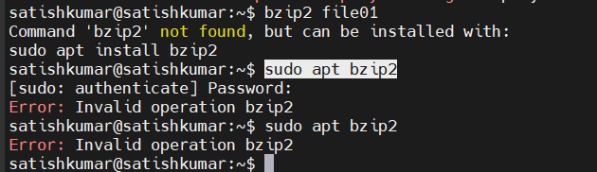

xz: High compression utility.
Command : xz file_A file_B
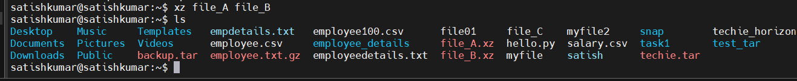

ZIP
zip Command in Linux
The zip command is used to compress one or more files and directories into a single .zip archive. Unlike gzip, bzip2, and xz, zip can compress directories directly

Command : zip demofile myfile myfile02
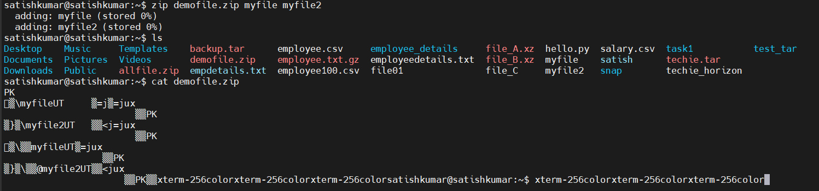

Command : zip -u backup.zip file.txt
Update an Existing ZIP Archive

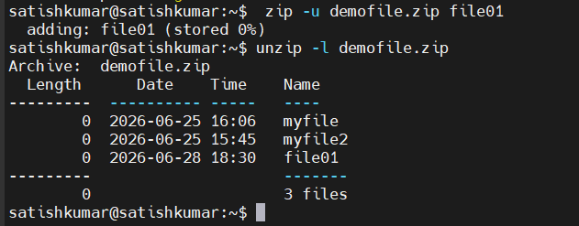

Command : unzip backup.zip -d /home/satishkumar/
Extract to a Specific Directory
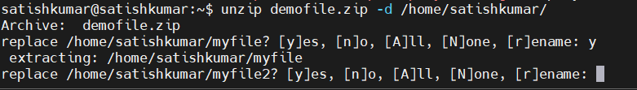
Delete a File from ZIP Archive
zip -d backup.zip file.txt
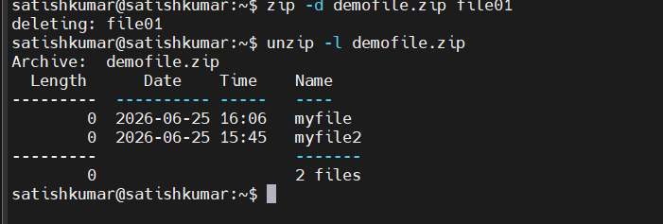

Encrypt a ZIP File with Password
Command : zip -e secret.zip file.txt
You'll be prompted to enter a password.

Display ZIP File Information
Command : zip -sf backup.zip
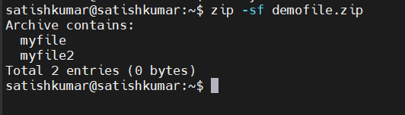

file: Determines the type of a file.
Example: file image.jpg displays the type of image.jpg.

Command : tourch image.jpg
Command : find ~/ -type f \( -iname "*.jpg" -o -iname "*.jpeg" -o -iname "*.png" \)
Download image
Command : wget https://picsum.photos/300 -O image.jpg
Command : file image.jpg
Command : stat image.jpg
Command : file -i image.jpg
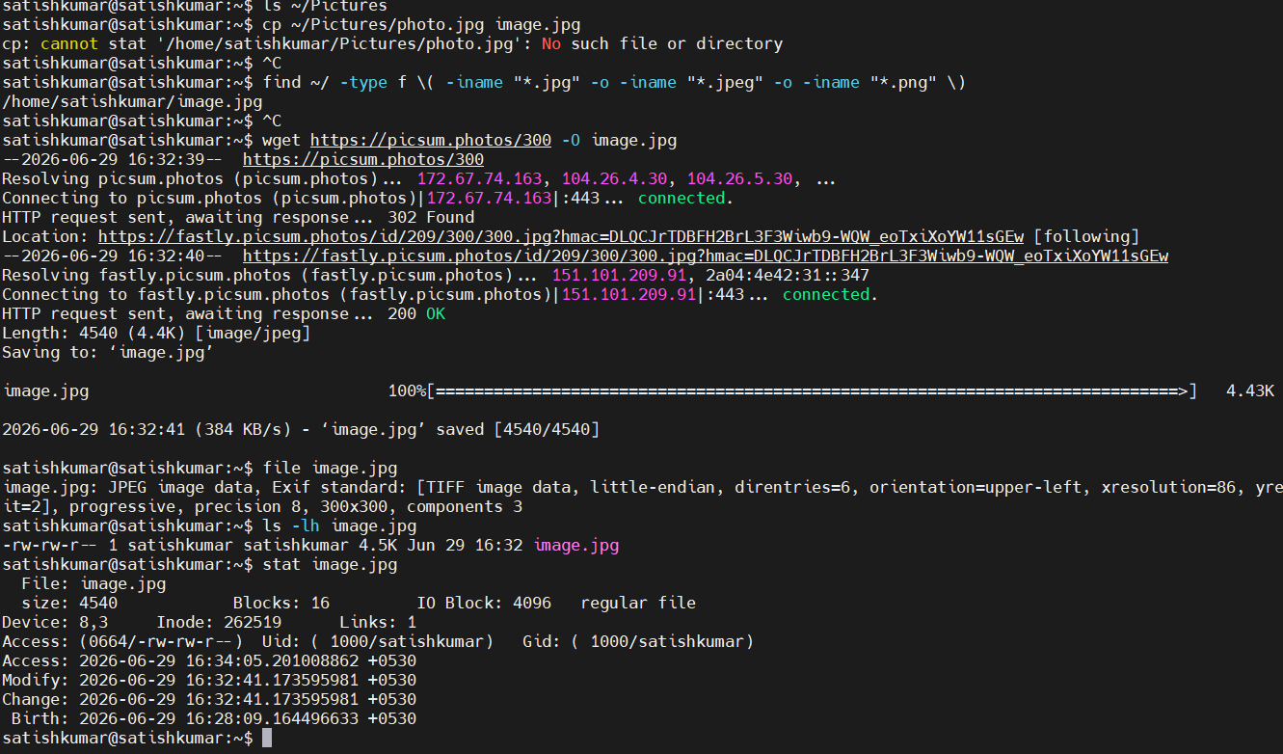

mount: Attaches a filesystem to a specified directory.
Definition
The mount command is used to attach (mount) a filesystem from a storage device (hard disk, USB drive, CD/DVD, network share, etc.) to a directory (called a mount point) so that its files can be accessed.
1: Mount a Disk Partition
sudo mount /dev/sdb1 /mnt
2: Mount a USB Drive
sudo mount /dev/sdc1 /media/usb
3.View All Mounted Filesystems
Mount
Mount a CD/DVD
sudo mount /dev/cdrom /mnt

df: Displays disk space usage of all mounted filesystems.
- Example: df -h shows disk space in human-readable format.
Description: Useful for monitoring disk space usage
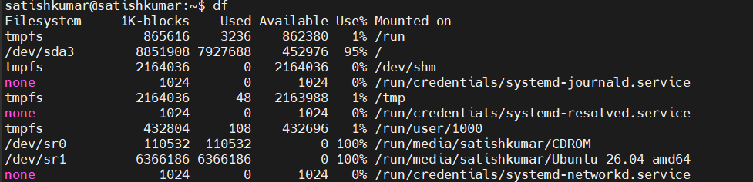

df -h
df -T
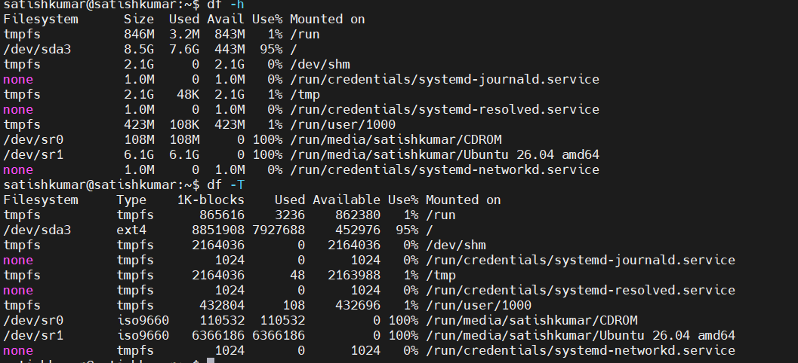

findmnt: Lists all mounted filesystems.

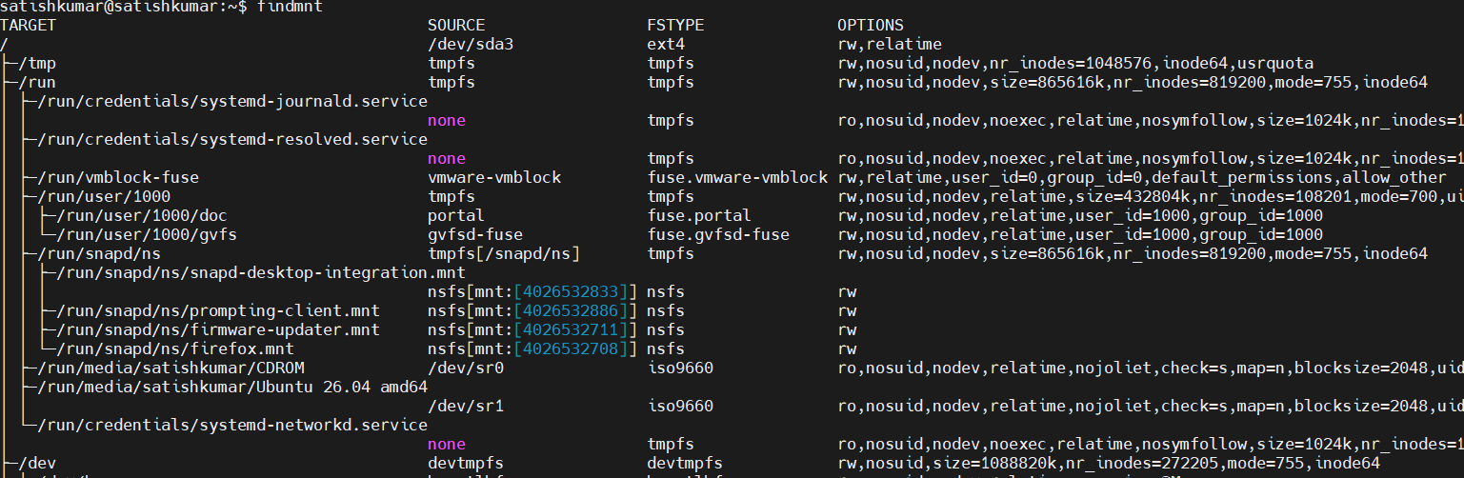
Command : findmnt -t ext4
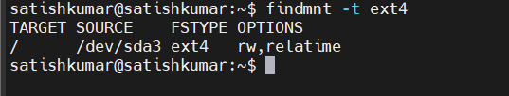
Display a Specific Mount Point
findmnt /

Show the Source Device
findmnt -S /dev/sda3
Display Mount Options
findmnt -o TARGET,SOURCE,FSTYPE,OPTIONS

lsblk: Lists information about block devices.
The lsblk (List Block Devices) command displays information about block devices such as hard disks, SSDs, USB drives, CD/DVD drives, and their partitions in a tree-like format.
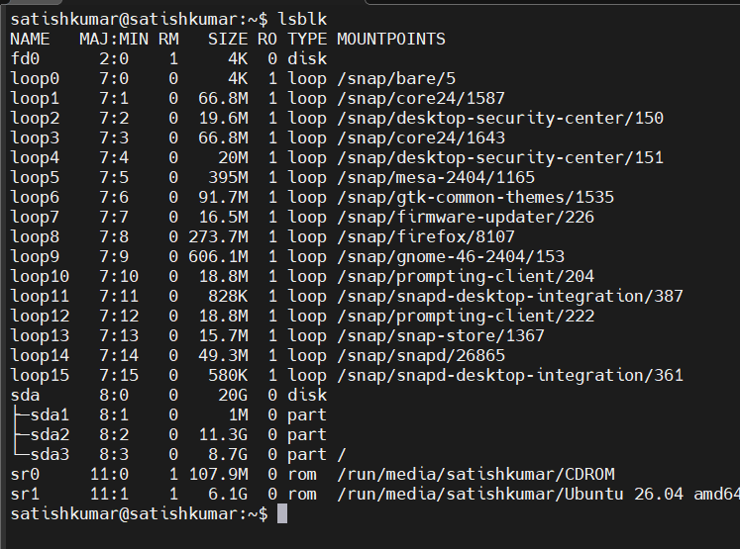

Working with Text Files Commands
nano
Command : nano notes.txt

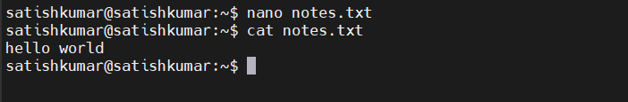
vimtutor
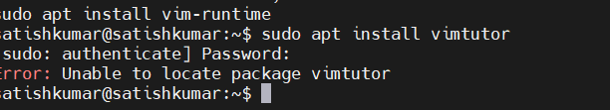
Vi
Command : vi notes.txt

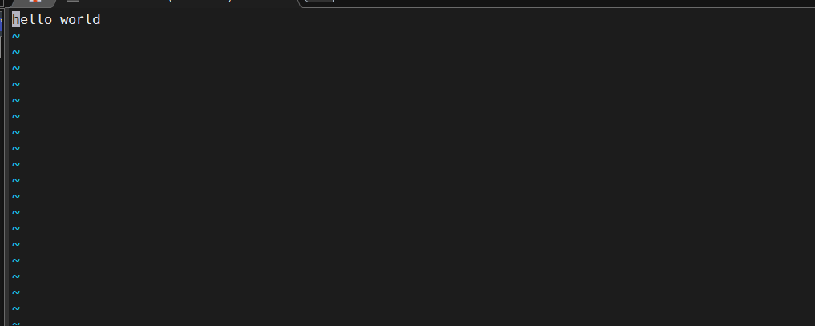
Vim
Command : vim notes.txt


More
A pager to view the contents of text files, one screen at a time.
Command : more notes.txt
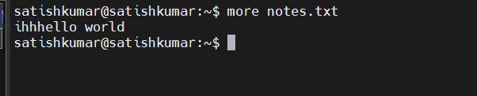

less
Description: Similar to more, but provides more control over viewing text files.
Command: less employee100.csv
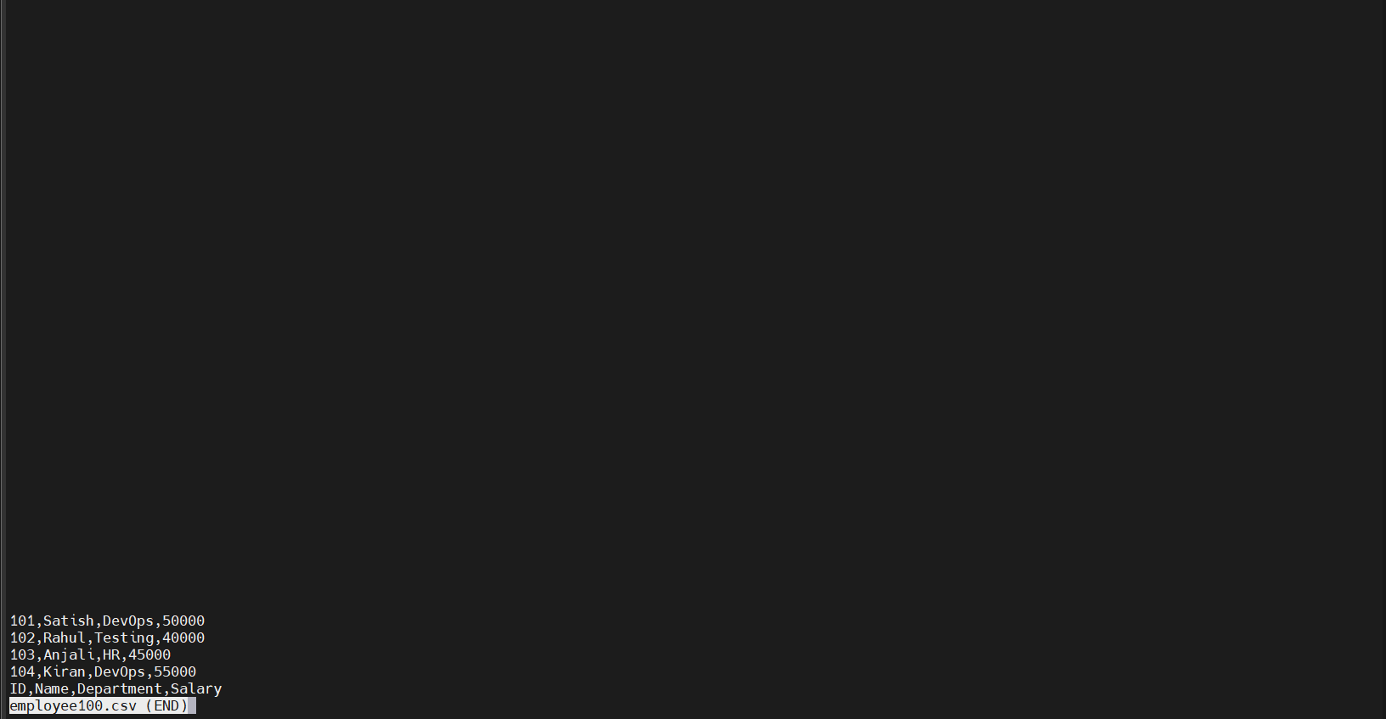

head
Description: Displays the first few lines of a text file.
Command : head -3 employee100.csv
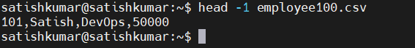

tail
Description: Displays the last few lines of a text file.
Command : tail -2 employee100.csv
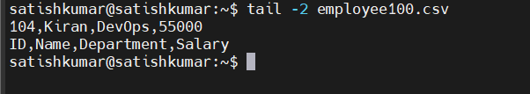

cat
cat -A
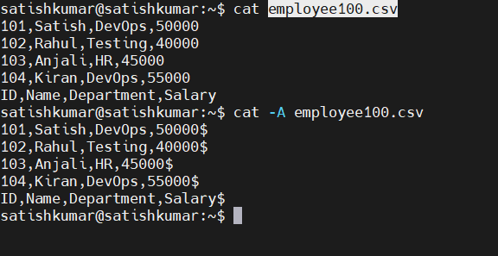

tac
Description: Prints the contents of a text file in reverse order.
Command : tc test01
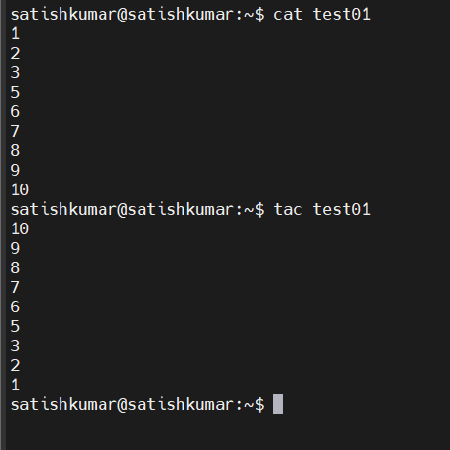
grep
Searches for text in files or command output
1.Search for a keyword in a specific log file
Command :grep -I “error” syslog
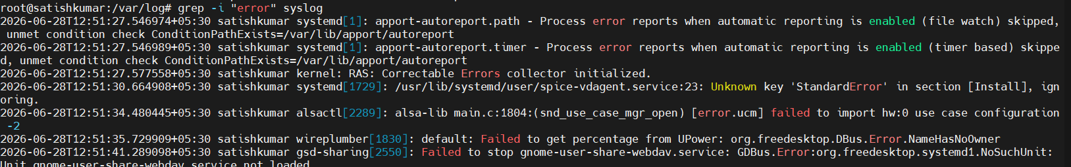

2.Search in all log files
Command : grep -ri "error" /var/log
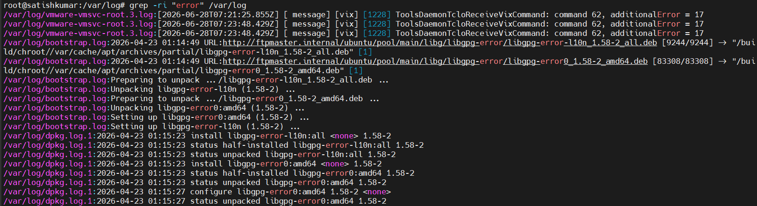

3.Display only the log files containing the keyword
grep -ril "error" /var/log

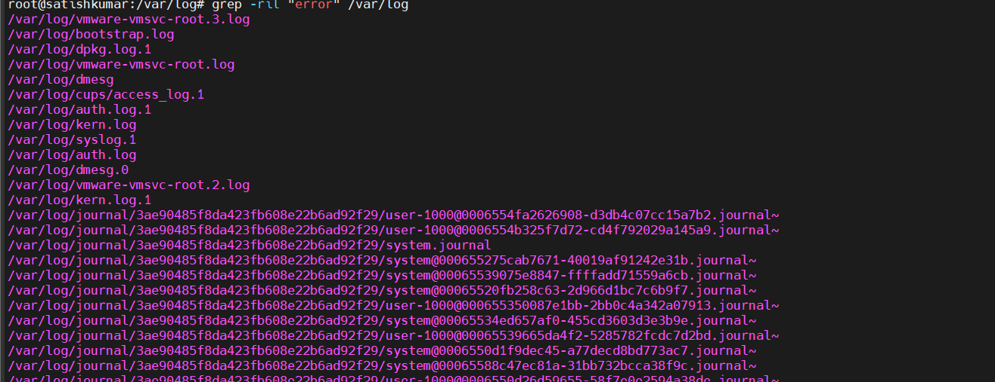

4.Count how many times the keyword appears
grep -ic "error" /var/log/syslog

Show line numbers
grep -in "error" /var/log/syslog
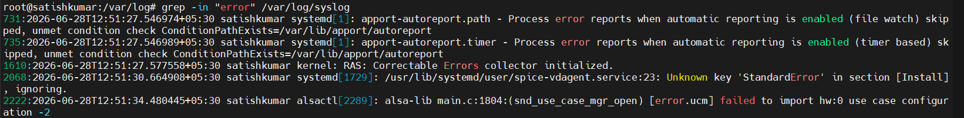
Search for multiple keywords
grep -iE "error|failed|fatal|exception" /var/log/syslog
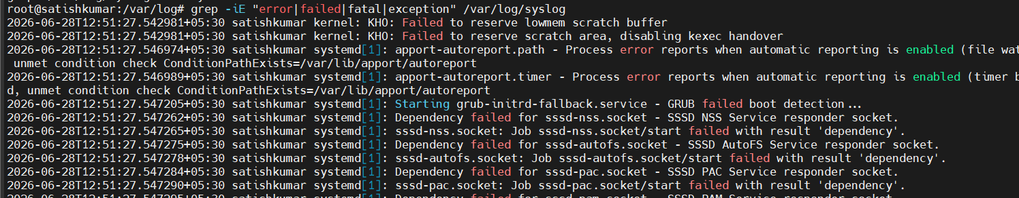

Search only .log files
grep -ri "error" /var/log/*.log
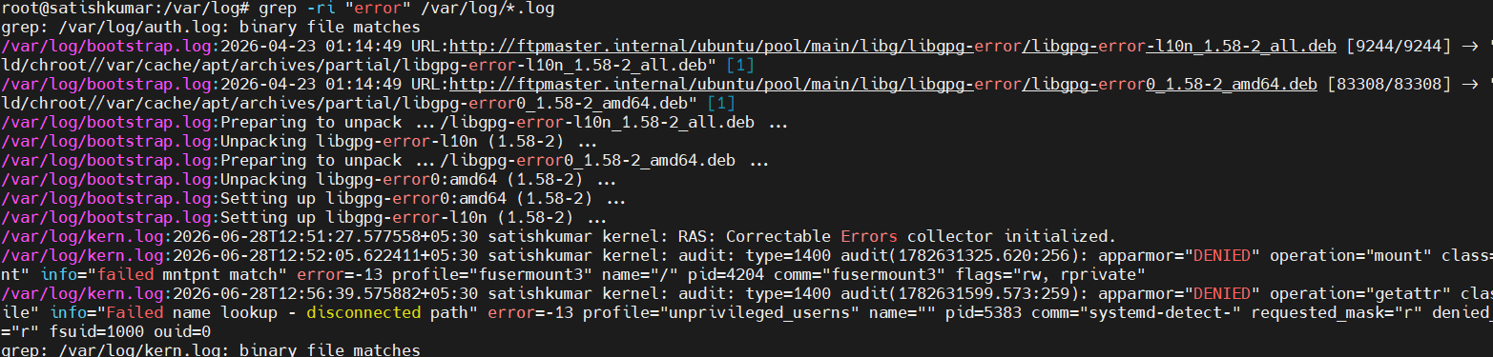
Search Apache logs
grep -i "404" /var/log/apache2/access.log
Search Tomcat logs
grep -i "Exception" /opt/tomcat/logs/catalina.out
awk
awk is a powerful text-processing command used to search, filter, format, and manipulate structured text files. It processes input line by line and divides each line into fields, making it ideal for working with log files, CSV files, and command output.

Option 1: Create a sample file
Create a file:
echo -e "John HR 50000\nAlice IT 60000\nBob Finance 55000" > file.txt
Check the file:
cat file.txt

Now try these awk commands:
Print all lines:
awk '{print}' file.txt
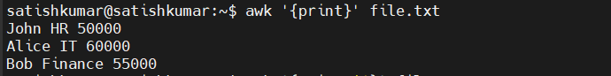
Print the first column:
awk '{print $1}' file.txt
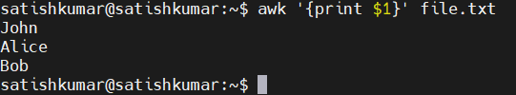
Print the first and third columns:
awk '{print $1, $3}' file.txt
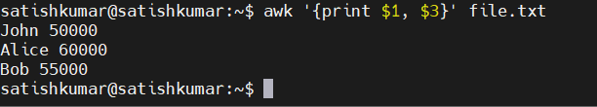

Search log files with awk
1. Search for a pattern in a log file

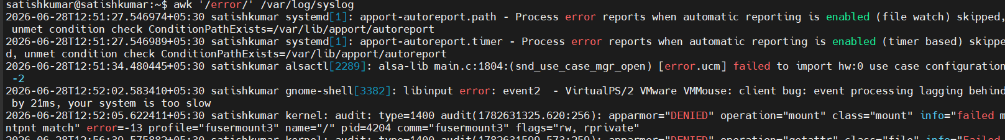
2.Search for failed login attempts
awk ’Failed’ /var/log/auth.log
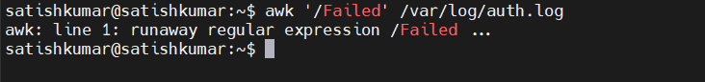

3.Print only the first column (IP address) from Apache access log
awk '{print $1}' /var/log/apache2/access.log
4.Print date and time from syslog
awk '{print $1, $2, $3}' /var/log/syslog
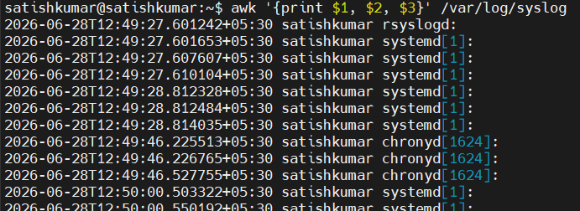

5.Print username and shell
awk -F: '{print $1, $7}' /etc/passwd
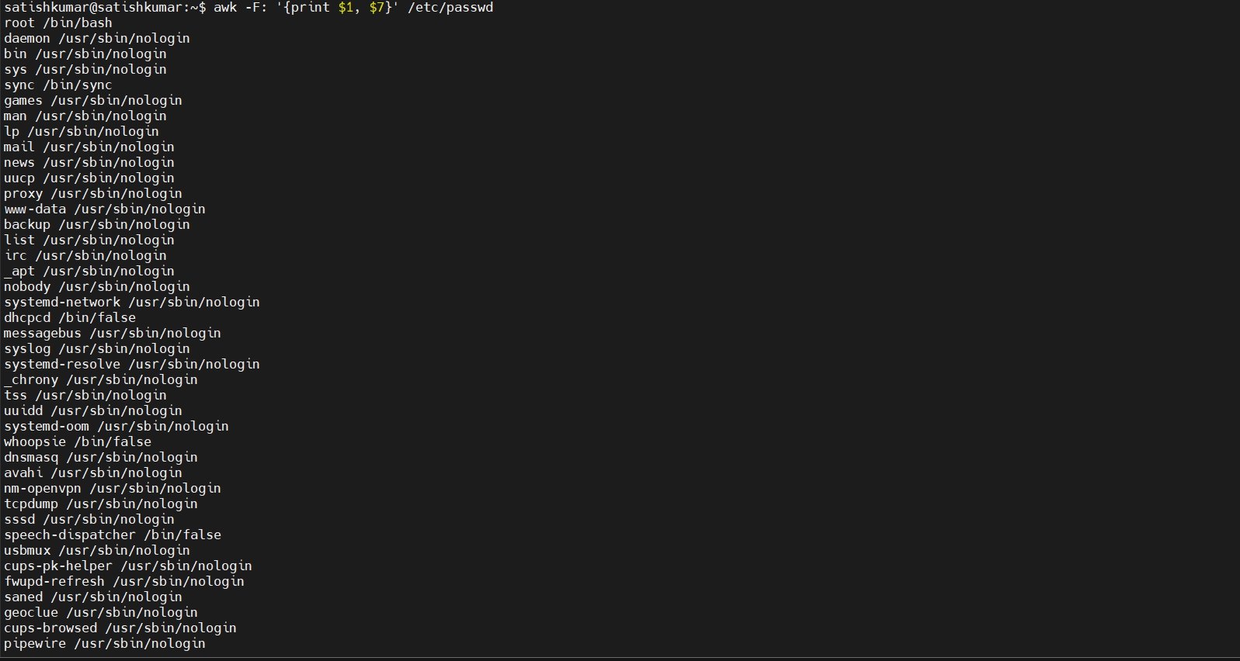

6.Filter only ERROR messages
awk '/ERROR/' /var/log/syslog
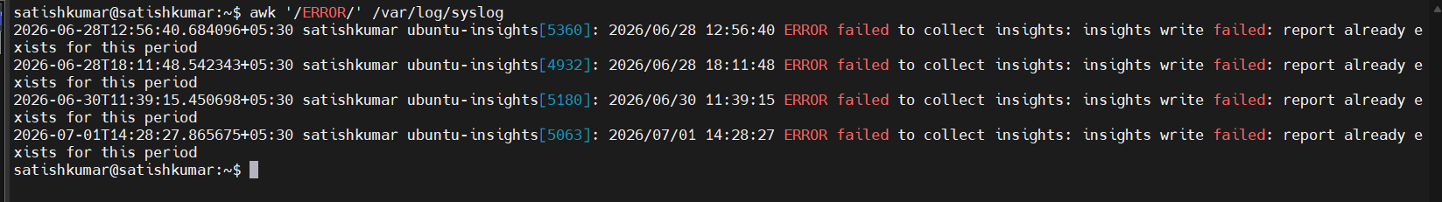

7.Show processes using more than 10% CPU
ps -eo pid,user,%cpu,comm | awk '$3 > 10'
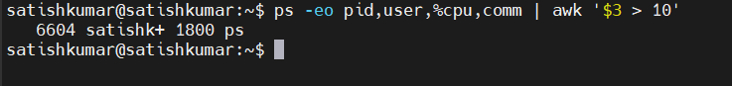
7.Show mounted filesystems
df -h | awk '{print $1, $5}'
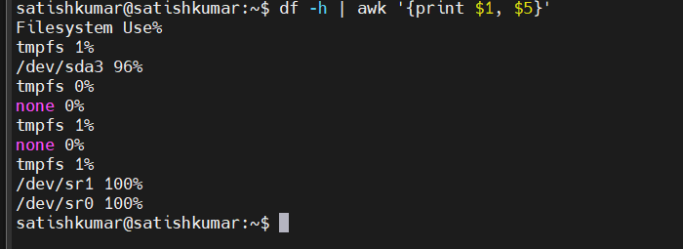
8.Count log entries
awk 'END {print NR}' /var/log/syslog

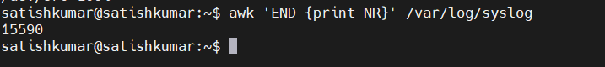

9.Find SSH login messages
awk '/sshd/' /var/log/auth.log
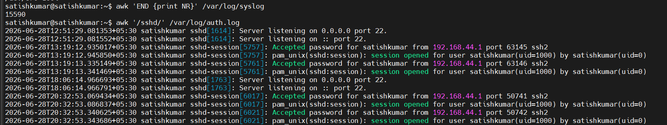

Sed
# Display the first 10 lines of a log file
sed -n '1,10p' /var/log/syslog
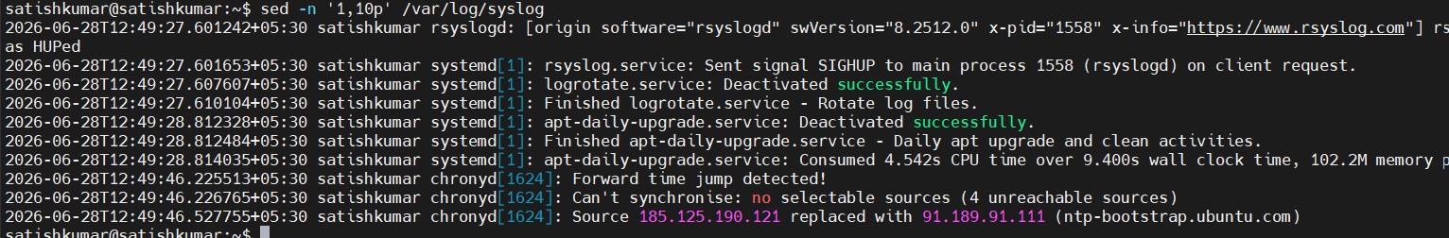
# Display lines 20 to 30
sed -n '20,30p' /var/log/syslog 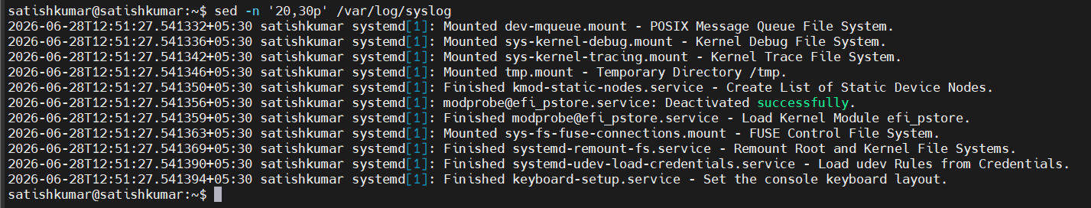

# Display the last few configuration lines (combined with tail)
tail -20 /etc/ssh/sshd_config 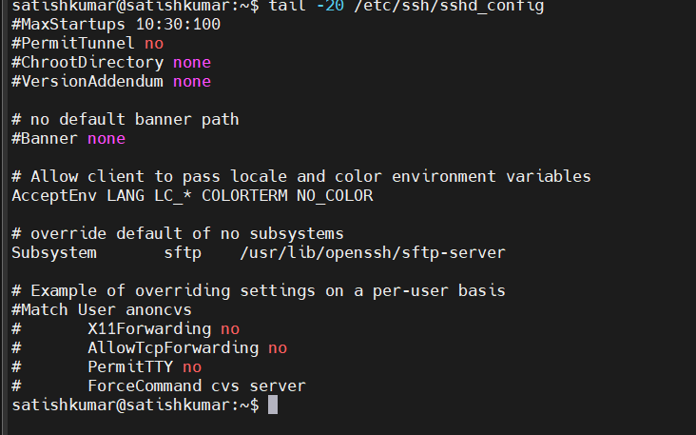

# Print only lines containing "error"
sed -n '/error/p' /var/log/syslog 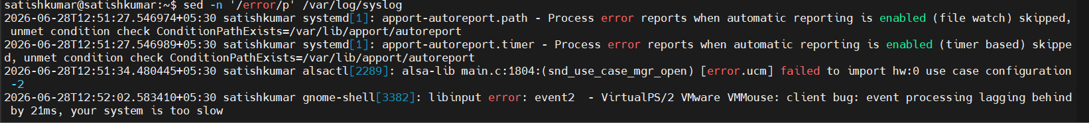

# Print only lines containing "Failed"
sed -n '/Failed/p' /var/log/auth.log

tar
The tr (translate) command is used to translate, replace, delete, or squeeze characters from standard input. It is commonly used with pipes (|) in Linux administration.

# Convert lowercase to uppercase
echo "linux administrator" | tr '[:lower:]' '[:upper:]'

# Convert uppercase to lowercase
echo "LINUX ADMINISTRATOR" | tr '[:upper:]' '[:lower:]'

# Replace spaces with underscores
echo "Linux System Admin" | tr ' ' '_'

# Replace colons with spaces (useful with /etc/passwd)
cat /etc/passwd | tr ':' ' ' 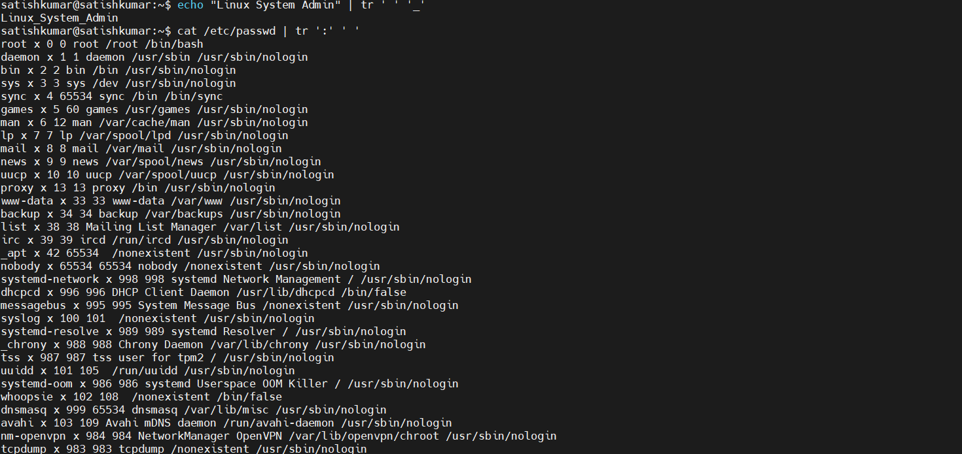

# Remove spaces
echo "Linux Admin" | tr -d ' ' 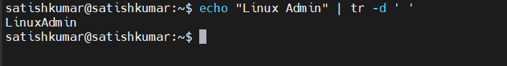

cut
# Display the first field (username) from /etc/passwd
cut -d':' -f1 /etc/passwd 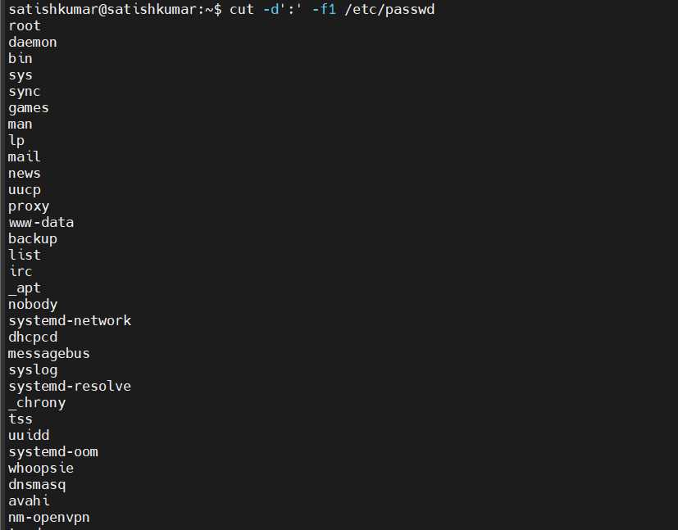

# Display username and home directory
cut -d':' -f1,6 /etc/passwd 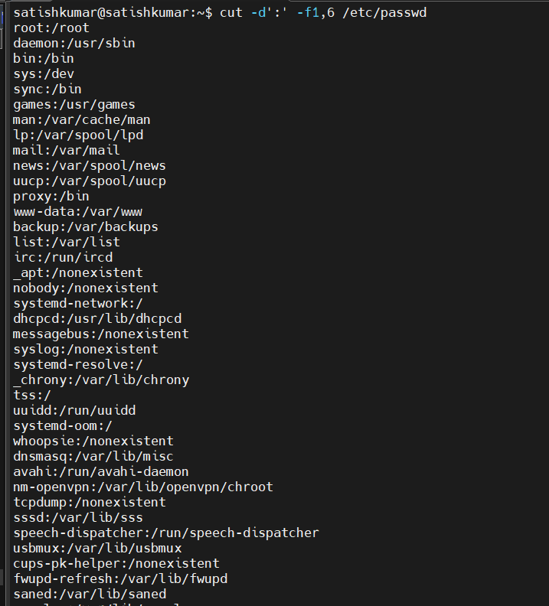

# Display only the shell used by each user
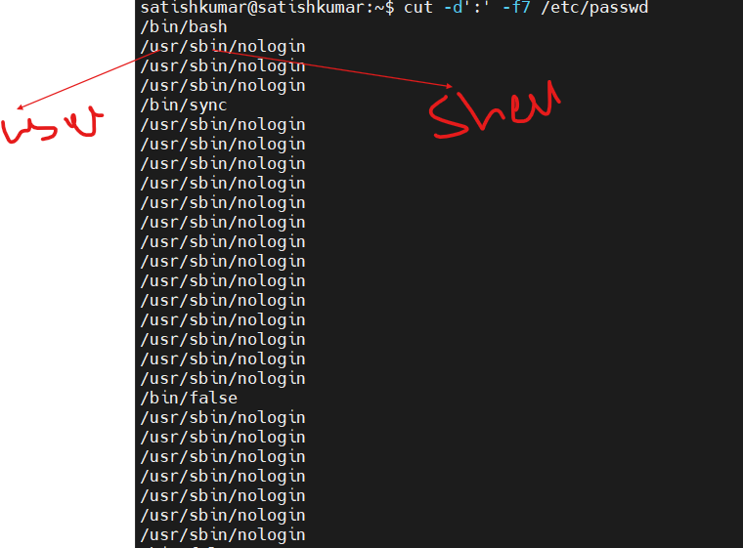
cut -d':' -f7 /etc/passwd

su

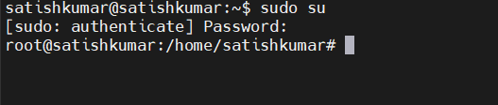
su

sudo
Ssh
he ssh (Secure Shell) command is used to securely connect to a remote Linux server over a network. It encrypts communication between the client and the remote server, making it the standard tool for remote administration.
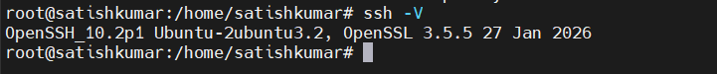

scp
Description:
The scp (Secure Copy) command is used to securely copy files and directories between local and remote Linux systems over SSH.

# Copy a local file to a remote server
scp file.txt username@hostname:/home/username/
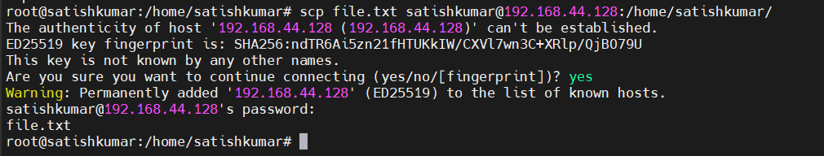
# Download a file from a remote server
scp username@hostname:/home/username/file.txt . 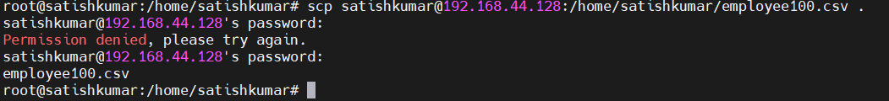

# upload the file to the remote server
scp employee100.csv satishkumar@192.168.44.128:/home/satishkumar/
# Download to a Specific Directory
scp satishkumar@192.168.44.128:/home/satishkumar/employee100.csv /home/satishkumar/Downloads/

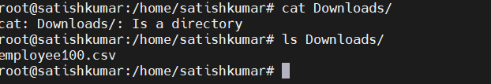
# Save disk usage information
df -h | tee disk_usage.txt 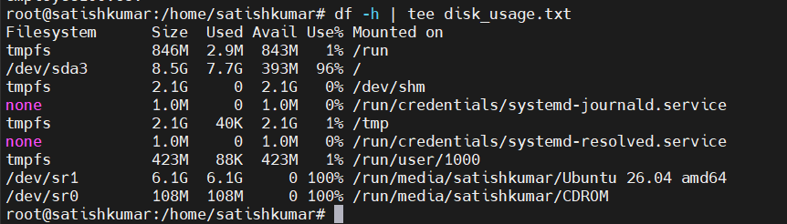

Save installed packages
dpkg -l | tee installed_packages.txt 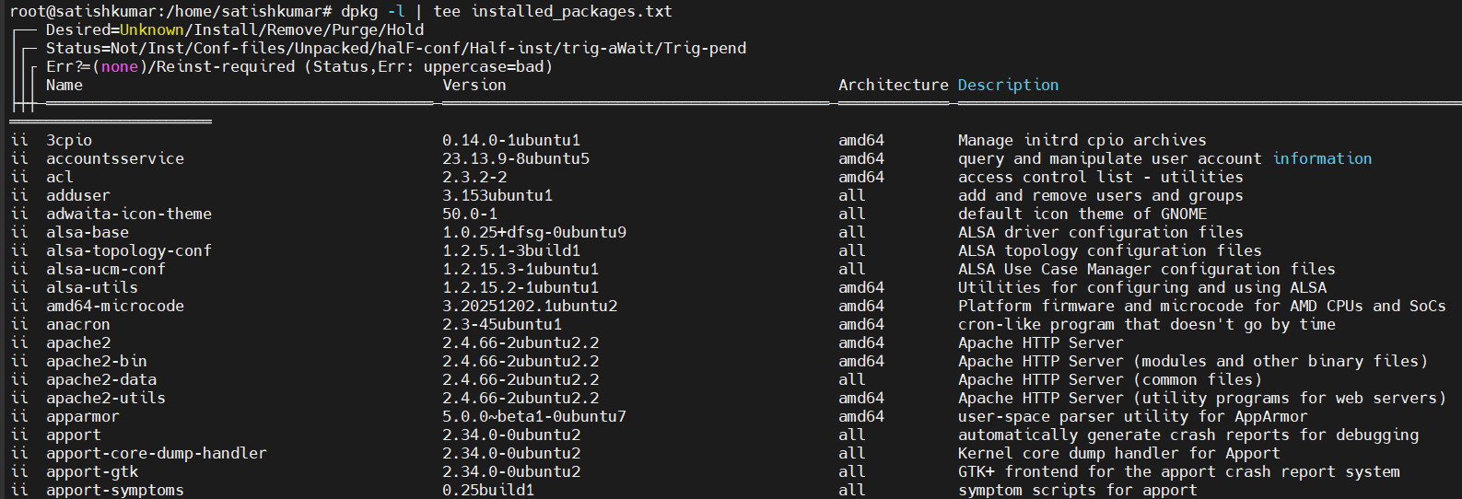

# Save network configuration
ip addr | tee network_info.txt 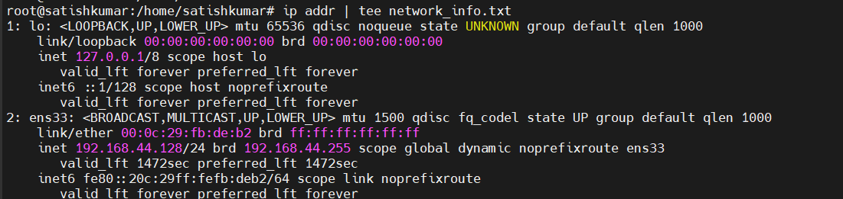
The output is saved in the current working directory, unless you specify a different path.
Ls-lh
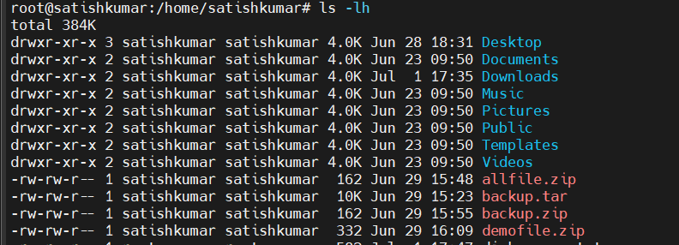

Search for the file if you don't know where it was saved
find /home -name "disk_usage.txt"
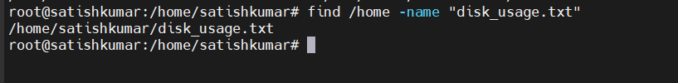

History
Display all command history
history 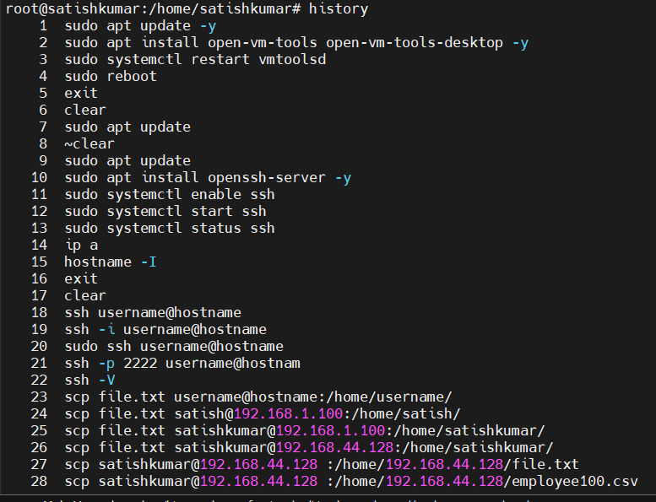
# Display the last 10 commands
history 10
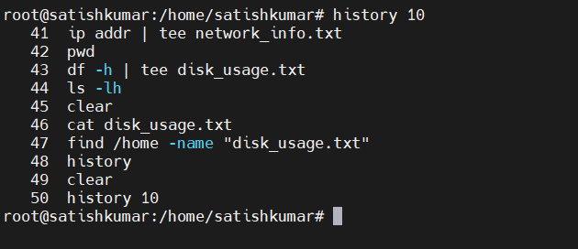
# Search history for SSH commands
history | grep ssh 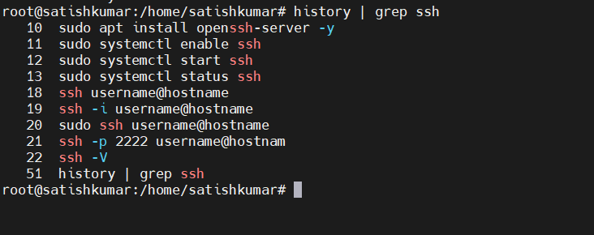
# Search history for SCP commands
history | grep scp 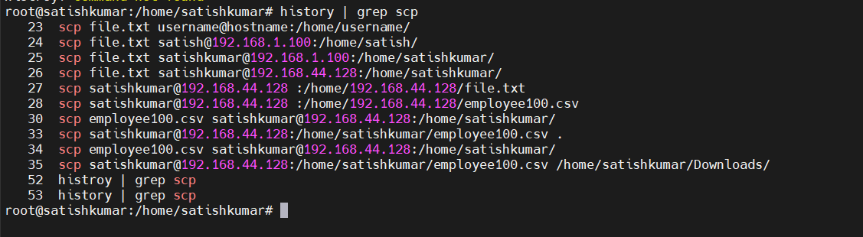
Adds users
Command: useradd

User and Group Management and Permissions Commands

We need to conform directory which directory we are in, we need root directory to create user
pwd
Sudo su -- go to root
adduser
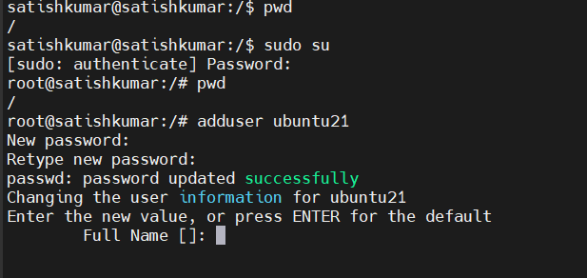
Permissions :Modifies user properties
Command:usermod

Verify the user Check that the user was created:
Command : cat /etc/passwd | grep ubuntu21
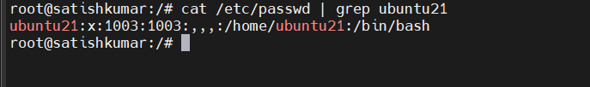
#! (Shebang): The magic character sequence (# and !) that tells the system this file is an executable script rather than a compiled binary.
/bin/: The system directory where fundamental, essential command binaries (like ls, cp, and shells) are traditionally stored

Switch to the new user
su - ubuntu21

Give the user sudo privileges (optional)
If you want ubuntu21 to be an administrator:
usermod -aG sudo ubuntu21
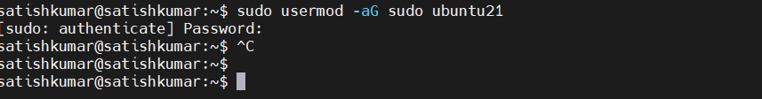

Userdel
The userdel command is used to delete an existing user account from a Linux system. It removes the user's account information from system files such as /etc/passwd and /etc/shadow.

sudo userdel ubuntu21 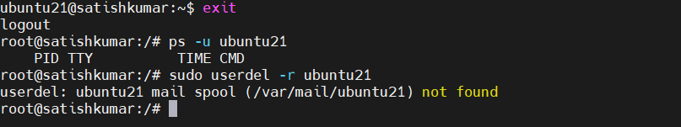

groupadd
The groupadd command is used to create a new group in Linux. Groups help organize users and simplify permission management by allowing multiple users to share access to files, directories, and resources.
Create a New Group
Create a group named developers:
sudo groupadd developers
Verify:
grep developers /etc/group 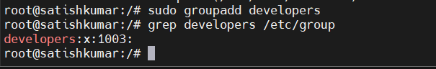

groupmod
The groupmod command is used to modify an existing group in Linux. You can use it to change the group name or the Group ID (GID).
Rename a Group
Rename the group developers to devops:
sudo groupmod -n devops developers
getent group devops
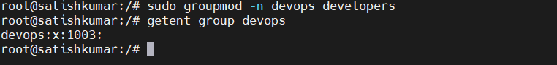

groupdel
The groupdel command is used to delete an existing group from a Linux system. It removes the group's entry from the /etc/group and /etc/gshadow files.
sudo groupdel devops
grep devops /etc/group
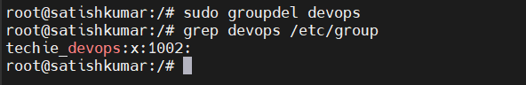

id
The id command is used to display information about a user account, including the User ID (UID), Primary Group ID (GID), and all groups the user belongs to.
id -u satishkumar
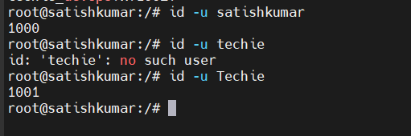

getent
The getent command is used to retrieve entries from the system's administrative databases. These databases include users, groups, hosts, services, protocols, and more. Unlike directly reading files such as /etc/passwd, getent can also retrieve information from network directory services like LDAP, NIS, or other configured sources.
getent passwd satishkumar 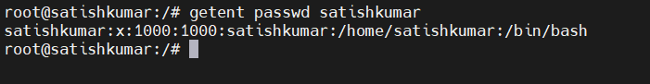
passwd
set new passwas
passwd
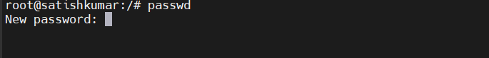

chage
The chage (Change Age) command is used to manage password aging policies for Linux user accounts.

Display Password Aging Information
sudo chage -l satishkumar
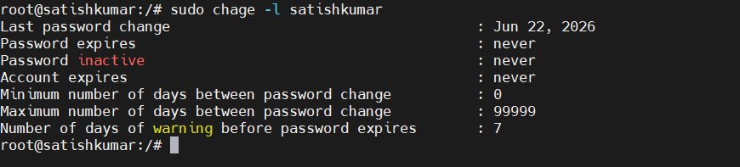
2. Set Password Expiration to 90 Days
sudo chage -M 90 satishkumar
3.Set Minimum Password Age
sudo chage -m 7 satishkumar

4.Set Password Expiration Warning
sudo chage -W 7 satishkumar

5.Set an Account Expiration Date
sudo chage -E 2026-12-31 johndoe
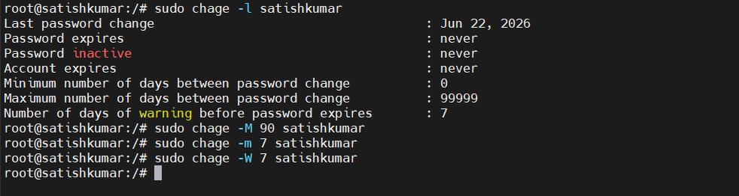
Command | Purpose
sudo chage -l johndoe | Display password aging information
sudo chage -M 90 johndoe | Set password expiration to 90 days
sudo chage -m 7 johndoe | Set minimum password age
sudo chage -W 7 johndoe | Warn 7 days before password expiration
sudo chage -d 0 johndoe | Force password change at next login
sudo chage -E 2026-12-31 johndoe | Set account expiration date
sudo chage -I 30 johndoe | Lock account after 30 inactive days following password expiration

w
The w command is used to display information about users who are currently logged into the system and what they are doing
w
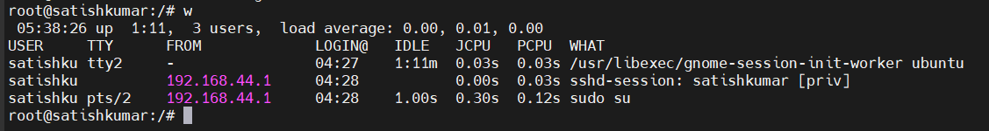
W -i
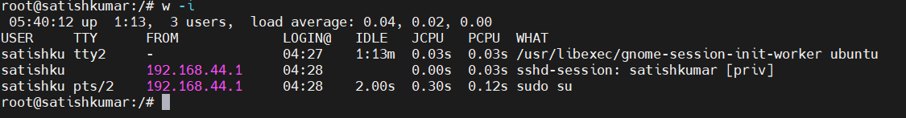
who
The who command is used to display information about users who are currently logged into the Linux system. It shows details such as the username, terminal (TTY), login time, and remote host (if connected via SSH).
vipw
The vipw command is used to safely edit the /etc/passwd file, which stores user account information. Unlike editing the file directly with editors like vi or nano, vipw locks the password database while you are editing it, preventing other users or processes from making changes at the same time.

sudo vipw
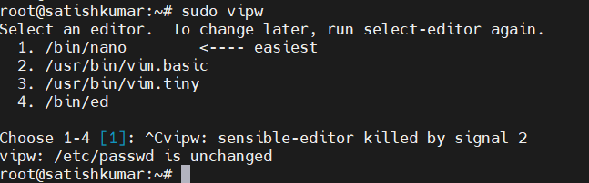

Log Files Commands
Command: journalctl

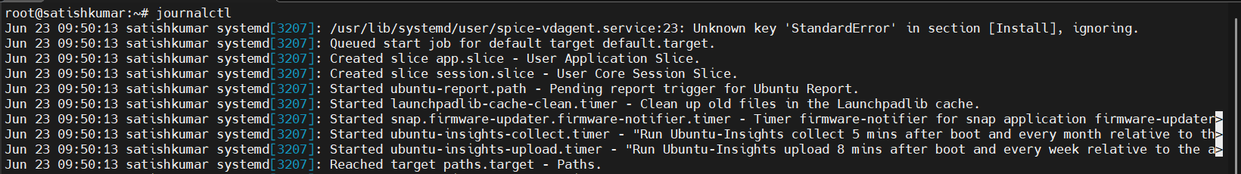
The journalctl command is used to view and manage logs stored by the systemd journal. It provides a centralized logging system that collects logs from the kernel, system services, applications, and system boot processes

View Logs for a Specific Service
Example: Nginx
sudo journalctl -u nginx

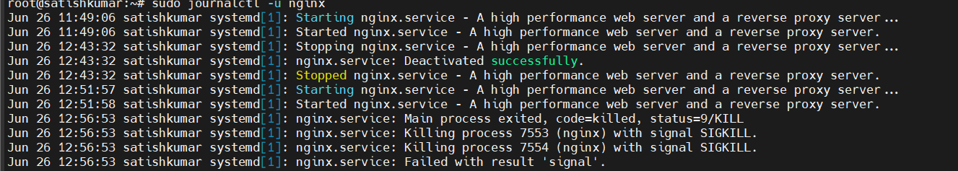

Command: tail
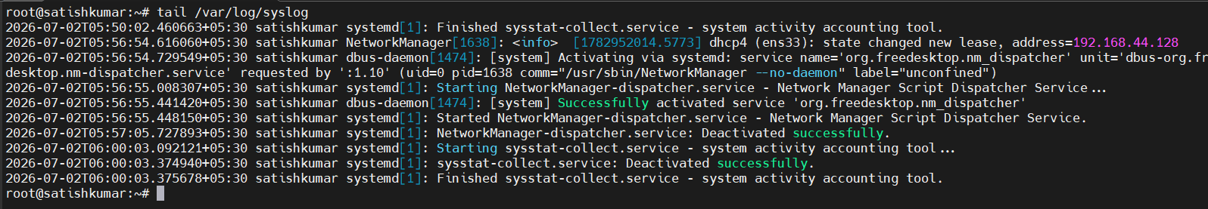
tail /var/log/syslog

Monitor a Log File in Real Time
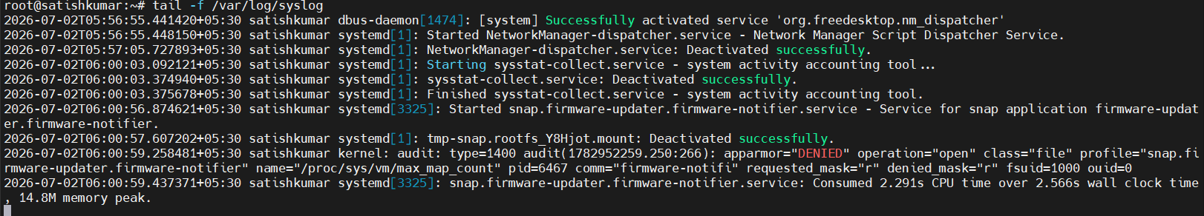
tail -f /var/log/syslog

Command: less
Open a Log File
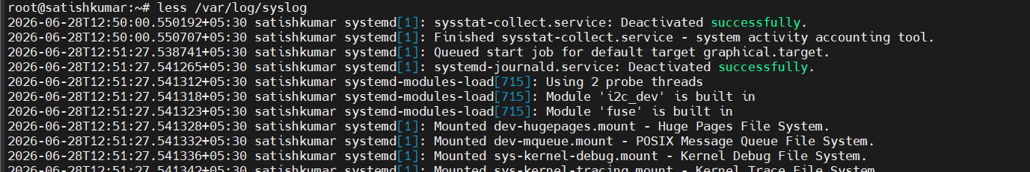
less /var/log/syslog

Open a File with Line Numbers
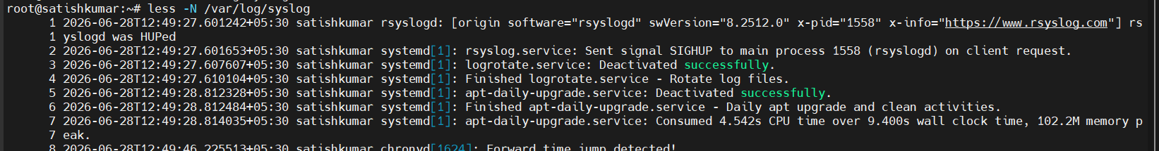
less -N /var/log/syslog

Command: logger
Description: The logger command is a convenient tool

Write a Simple Log Message
logger "Server backup completed successfully"
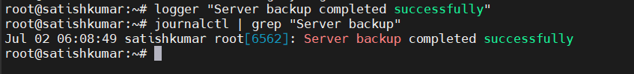
journalctl | grep "Server backup"

Write a Log Message with a Tag
logger -t Backup "Daily backup completed successfully"
verify: journalctl -t Backup

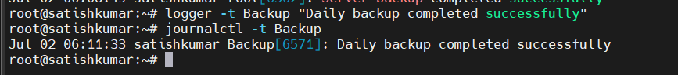


Scheduling Tasks Commands

